

*Report*

**CONSTRUCTION AND DEVELOPMENT   
WEBSITE THE CLO**

Instructor: MSc Phạm Mạnh Cường

Implementation Team: Group 5

*TP. HCM City, December, 2020*

# MEMBERS LIST

|  |  |  |  |  |
| --- | --- | --- | --- | --- |
| No. | Fullname | Student’s ID | Role | Email |
| 1 | Mai Nguyễn An Bình | K184060777 | Leader | [binhmna18406c@st.uel.edu.vn](mailto:binhmna18406c@st.uel.edu.vn) |
| 2 | Nguyễn Lê Phương Oanh | K184060797 | Member | [oanhnlp18406c@st.uel.edu.vn](mailto:oanhnlp18406c@st.uel.edu.vn) |
| 3 | Trịnh Thu Huyền Trang | K184060811 | Member | trangtth18406c@st.uel.edu.vn |

**TABLE OF CONTENTS**

MEMBERS LIST 1

CHAPTER 1: IDEA AND BUSINESS PLAN 4

1. Introduce the topic 4

1.1. Survey market and choose topics 4

1.2. Introducing fashion website THE CLO 5

2. Business analysis 6

2.1. Business goals 6

2.2. Business and product sectors 6

2.3. Market analysis 7

2.4. Analysis of competitive environment and competitive advantage 9

3. Business models analysis 11

3.1. Customer Segments 12

3.2. Value Propositions 12

3.3. Channels 13

3.4. Revenue Stream 15

3.5. Key Resources 15

3.6. Key Activities 17

3.7. Key Partnerships 17

3.8. Cost Structure 17

3.9. Marketing plan 18

CHAPTER 2: WEBSITE DESCRIPTION 23

1. General introduction 23

2. The basic structure of the Website is illustrated 23

3. Detailed description of the main components of the Website 24

3.1. Header & Footer 24

3.2. Home page 24

3.3. Sign up & Log in 26

3.4. The cart 28

3.5. Wardrobe 29

3.6. Lookbook 29

3.7. Blog 30

3.8. Contact 30

CHAPTER 3: CONCLUSION 31

1. Project evaluation 31

1.1. Result 31

1.2. Advantage and disadvantage 31

2. Development 31

REFERENCE 33

APPENDIX - Team working process report 34

1. Member list 34

2. Rules of work of the group 34

3. Assign tasks and completion schedule 35

3.1. Task Table 35

3.2. PERT Chart 35

3.3. GANTT Chart 36

4. Comment from the group 37

5. Summary 37

# CHAPTER 1: IDEA AND BUSINESS PLAN

## Introduce the topic

### Survey market and choose topics

* Nowadays, information technology has strongly developed in both breadth and depth. Electronic computers, phones, tablets, ... have become popular tools for working, searching for information and entertainment of almost all ages. According to the Vietnam E-commerce report 2019, in Vietnam alone, 66% of people access the internet. This is a potential opportunity for businesses and brands to reach their customers more easily, cost-effectively, and efficiently than before.

From the management software that makes the shop's sales work quick and easy, the Website was born not only to meet customers who come directly to the store to buy products but also serves customers goods far away. Not only that, the introduction and promotion of the image of the store and the company have been expanded on a large scale, making business, trading, and exchanging news much more convenient, bringing economic efficiency. Higher and create prestige in the hearts of customers. Because of the benefits that the Website brings to the stores, the company has applied it to develop their business and introduce their stores.

* Human life is improved and enhanced day by day, so human needs are also more and more developed. One of the areas that are increasingly demanding of people in the fashion market. Trends in recent years, consumer shopping demand increased sharply. According to the survey compared to other essential items, shopping for fashion products ranks third after spending especially for women.

The dressing is always the privilege of women, only when we are confident in the clothes on each step on the street, can we become the best version of ourselves, can we have a full day. However, in addition to food expenses, travel expenses, living expenses, and buying cosmetics, the amount of money to buy clothes is also extremely "huge". Just 1 or 2 beautiful clothes in one go shopping can cost you from 1 to 2 million. For this reason, women are always in a state of "out of pocket" when leaving the clothing shops.

* In this case, the exchange and rental of clothes is the optimal solution when it can solve both the cost problem as well as the "nothing to wear" of women. In particular, just spending a few tens of thousands, you can wear a satisfactory item, in accordance with your needs.

The exchange and rental of clothes mean that you will help prolong the life of the item, which also means you are participating in the direct recycling process. Instead of putting them in the trash, creating a large amount of waste, we are the ones who prolong the life, especially the number of clothes produced and consumed each year. This has great implications for protecting the environment.

It is this that raises the question of fashion shops and businesses, how to meet the demand for fashion for women at a low cost and also for maintenance. environmental protection through website channel. That requires a quality Website for exchanging, renting clothes, providing images and content, updating fashion trends in a timely, fast, and continuous manner.

Keeping up with the development trend of the digital technology era and contributing to increasing the store's revenue, providing customers with an accurate and timely information channel, the team conducted research and design a Website page THE CLO to provide women's clothing exchange and rental services.

### Introducing fashion website THE CLO

* The fashion website THE CLO will provide a "large" space for you to freely choose the clothes you like with the price completely within your reach. From famous overseas clothing and clothing such as Uniqlo, Zara, H&M, Pull & Bear ... or even Vietnamese commercial clothes such as IVY MODA, She By Shj, Libé, The 19 Club, OUTFIXSAIGON, ... are available for sale. . What you want to buy, then immediately have that. You want the price to be cheap, rest assured, it is even cheaper than you think. Through this CLARITY fashion website, you will quickly find the item you like.

THE CLO is the sharing economy platform for fashion. Instead of the traditional model of having to buy and own fashionable products to use and experience, THE CLO allows users to pay a flat monthly fee to use and experience the products. fashion without ownership

* By making the possession and purchase of fashion products "select" instead of "obligatory" as traditional models, THE CLO enables users to enjoy fashion as easily and freely as possible. and at the same time minimizing waste in fashion.

THE CLO website provides a full range of company information, news, vision, mission, and career opportunities as well as ways to contact the company. Besides, the Website provides extremely useful information about products, sizes, brands in many different styles, suitable to each individual's preferences.

The most important part of this Website is the selection of products, display of product information, exchange, commenting, ordering, and returning goods as well as the sanctioning policies if the customer violates the agreement. such as evaluating and scoring product quality after use.

To be able to use this Website, customers need to register for membership with a fee of 50,000 VND/ day, the quantity of 5 items/time, and the quantity is unlimited.

If you are still "head up" with the question "What to wear today?" This website will rely on AI to learn about your body index, favorite colors, and style you are following as well as keep up with new fashion trends, to come up with a great outfit to respond to. meet your needs.

The CLO fashion website also regularly publishes articles on clothing mix as well as comments on daily fashion issues. This is really essential for those who are shaping and pursuing their style.

## Business analysis

### Business goals

* Increasing brand awareness of the store is creatively designed in a modern style, the outfits are presented in a minimalist layout, convenient according to customer needs and behavior.
* Continuously update trends, main styles, and colors so that customers can quickly and promptly grasp information. Increasing interaction with customers anytime, anywhere, there is no limit in space or time. Through the website, customers have positive or negative feedback to quickly withdraw shortcomings and correct them.
* Help effectively in collecting data about career, style, favorite color. From there, combining with technology solutions such as recommendation systems to make the most effective prediction about suggested clothing models for each customer. From there, the store can understand the wishes as well as the needs of the customer and make adjustments accordingly.

### Business and product sectors

* The business is about time spent on dress exchange under the management and administration of THE CLO fashion website.
* Overcoming the stereotypes about used goods, the fashion website THE CLO boldly invested and developed this new business model. Although still quite new, but this will surely be a brilliant success model in the future.
* The main products being traded are costumes through the exchange of "hot" costumes which are chosen by many people. Because this item is quite popular with young people, not only because of its unique and rarely encountered goods but the price is quite cheap and attractive, especially in the current stormy market.

### Market analysis

#### Market overview

The fashion rental model in Vietnam is still quite new and there are very few businesses doing business in this field. However, in other countries, especially big countries such as China, America, .. this model is quite popular and receives great attention and reception from consumers. The biggest factor that helped this model win the deep attention of the user is its low cost and convenience. We expect that with the current population in Vietnam, along with the advantages of this model, in the future if developed and built strategically, this will be a very successful business model.

#### Factors affecting the market

* Market size of the fashion market

Expanding market share in Vietnam is actually not easy for both foreign and domestic firms. After quickly gaining success in a few big cities, most of them slowed down, could not reach other provinces because the prices were still quite high and the designs were not suitable to the tastes of most. Vietnamese people. The expansion journey of Vietnamese fashion brands is even more arduous when many consumers still prefer unknown origin products, counterfeit products ... In particular, many fashion companies in Vietnam are still managing according to the model. family, so the competitiveness of a new model-out rate is not high.

* The growth rate of the fashion market

The size of the Vietnamese fashion market is assessed to be attractive, thereby attracting more and more new brands to enter. According to statistics from market research firm Statista, the size of the Vietnamese clothing market in 2019 is estimated at US $ 5.6 billion with an expected growth of 8.8% per annum in the 2019-2023 period.

* Market trend of the fashion market

Many international brands have entered Vietnam in recent years such as H&M, Zara, Cutton On… This proves that the home market is potential and has many development opportunities.

Along with the "penetration" trend of many international names, domestic brands are also developing more and more. However, the fashion business of Vietnamese brands has a color of spontaneity and this will continue in 2020.

Fashion business is dominated by social networks and media. According to analysis data from We Are Social - digital advertising agency, in 2019, Vietnam reached the milestone of approximately 97 million people, of which about 64 million Internet users. On average, Vietnamese spend 6 hours and 42 minutes per day participating in activities on the Internet, of which 2 hours and 23 minutes are spent on social networks. It can be seen that Vietnamese people love social networks, can share almost anything on Facebook, Instagram ... creating better opportunities for businesses to sell, build images and develop brands.

* Court of law of the fashion market

According to the current law, fashion business is not on the list of conditional business lines. This means that any person who wants to run a fashion business just needs to go through the business registration process without meeting capital requirements, head office or sublicensing license.

* Relevant demographic and lifestyle factors



Population pyramids 2020, source danso.org

The customer segment targeted by the fashion rental business model is young people who are economically self-reliant. This is a potential customer segment because there are features that match the services of this business form. Young people always want to assert themselves and their personality in many ways, achievements, talents, style, ... Time, beauty, youth and fresh spirit are words to talk about gender. However, most young people often do not have financial strength, and the solution that fashion rental model offers can solve this problem. Young people can comfortably express their style without having to worry about costs.

* Customer's location (local, regional, national or international)

During the year, in the first quarter, the demand for entertainment and partying of people increases because this is the peak quarter of the festival season, so the demand for fashion is also higher than usual. Especially in big cities such as Ho Chi Minh City, Da Nang, Hanoi, ..., this need is even more evident through encouraging people to shop, bold discount campaigns by businesses, shops, ... In order to maximize revenue, businesses operating under the fashion rental model need to quickly grasp market demand and provide incentives and stimulus for consumers to use products and services. service.

In addition, areas with large economic activities and international exchanges often have higher demand than other regions all year round. City, Ho Chi Minh City, Da Nang, Hai Phong, Hanoi. The main characteristic of the population of this area often has the largest number of middle to highest income people in the country, so the demand for fashion is also very important.

#### SWOT analysis for fashion market

|  |  |
| --- | --- |
| **STRENGTHS** | **WEAKNESS** |
| -Environmental protection, creating sympathy for consumers  -Meet the dress needs of many ages and professions | -The disposition of the product after hire by a customer can result in product damage if incorrect  -New company established, small scale |
| **OPPORTUNITY** | **THREATS** |
| -There aren't many similar business models  -High number of potential customers, potential markets  -Diverse marketing channels  -Potential in association with big and small fashion brands | -People with high demand for services are often concentrated in big cities  -Compete with cheap clothes |

### Analysis of competitive environment and competitive advantage

In Vietnam, the idea of clothing rental has been around for a long time, businesses and individuals trading clothes rental model are not only concentrated in each big city but scattered in all provinces. country. However, these businesses and individuals are very small in size and target customers in their neighborhood. The products they rent out are not usually fashionable at an average price point. If it is invested and has a full and reasonable business strategy, the fashion rental model that we mentioned can capture a large market share because there are almost no enterprises doing business in this form in Vietnam. professionally.

Therefore, THE CLO's competitors will be clothing rental stores, secondhand store, and major fashion brands.

|  |  |  |  |
| --- | --- | --- | --- |
| **Competitor**  **Factorial** | **Rental stores, secondhand stores** | **Major fashion brands** | **THE CLO** |
| **Product** | -Mostly used outfits  -Origin of the product from many different sources  -Safety cannot be guaranteed due to the lack of an effective cleaning system | -The outfits are mostly designed and sewn  -The origin of the product clearly bears the names of major brands  -Ensure the safety because this is a new, unused product | -Mostly the costumes were reused over and over again  -The origin of the product clearly bears the names of major brands due to the cooperation with the brands  -Ensuring the safety because this is a product that has passed an effective cleaning system |
| **Price** | Not high | Very high | Medium |
| **Distribution channel** | At secondhand markets and secondhand shops | On major websites, E-commerce floors, ... | Websites, E-commerce floors, |
| **Public Relation** | No promotional policies, mostly spontaneous | Closely linking with customers to increase awareness | Collaborate with major brands to increase awareness |
| **Customer Segments** | Low-income person | High-income person | can be accommodated for low-income person and high-income person |
| **Key Activities** | Manual, without modern assistive devices | Having modern assistive devices to analyze and evaluate the market | Having modern assistive devices to analyze and evaluate the market |
| **Key Partnerships** | Clothing wholesalers | Designer, model, ... | Major fashion brands |
| **Cost Structure** | Low cost, mostly buy and sell. No costs for market research, business planning ... | High cost for market research, business planning | High cost for market research, business planning |
| **Revenue Stream** | Low revenue, mostly buy and sell | High revenue by attracting the market | Average revenue due to new presence in the market |
| **IT platform** | No using IT for bussiness | Using ERP, BI, Recommend System,… in bussiness | Using ERP, BI, Recommend System,… in bussiness |
| **Value Propositions** | Environmental Protection, limit the cost | Show your worth | Not only environmental protection, limit the cost but also show your worth |

## Business models analysis

Construction process:

* Build: Finalize a few important features and release the first release
* Measure: Bring products to potential customers to evaluate effectiveness
* Learning: Receive feedback from customers to add, remove, improve and supplement necessary elements. Lean Startup, breaking it down and making it small to save time and then testing it in the market to learn lessons is one of the keys to creating a FASTER feedback loop - LESS RISK - MORE BLOOD!
* Focus on approaching from the aspect of finding and solving problems to serve the main audience of startup entrepreneurs.
* Define by Collaborative Models: those events in which one or more persons consume economic goods or services in the process of engaging in joint activities with one or more others.

Collaborative Models in the Fashion Industry:

* Fashion swapping is a resource-saving initiative as it prolongs the items' lifetime since it is passed on to another consumer: "Fashion swapping is a resource-saving initiative because it prolongs the life of an item from the moment it is passed on to another consumer".
* The growing interest in renting is in light with a higher intolerance for wasteful consumerism in the fashion industry: "The growing concern with rental is due to the higher intolerance of wasteful consumerism in the fashion industry".

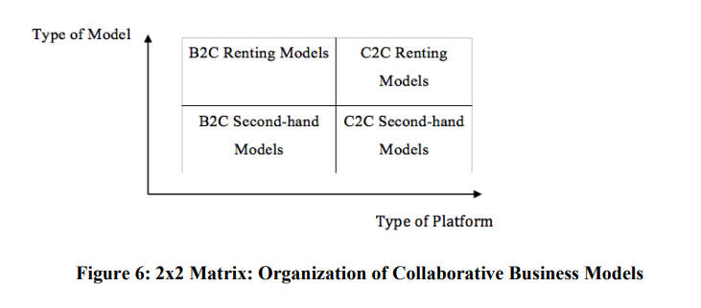

### Customer Segments

* People who have income: usually office workers, freelancers. This will be the main customer base of the company because this object needs to communicate a lot and regularly participate in meetings.
* KOL: are singers at the tea room or product promotion events, unpopular photos need to make albums to promote their image. With the need to frequently change outfits, the fashion rental business model is a very suitable economic solution for them.

### Value Propositions

* Use the new platform through the Internet to exchange, rent and purchase clothes.
* Thanks to this tool, it can reach many diverse customers, not only limited by space and time, but also access to many domestic and foreign sources.
* Demonstrating the outstanding development in business ideas, applying new technologies to maximize benefits for both businesses and customers.
* Increasing the reuse value of outfits, optimizing the cost that women need to spend to get their favorite outfits.
* Limiting the amount of waste clothes, and reducing environmental pollution by reusing clothes.

### Channels

#### Website

As the main tool for THE C.L.O to provide detailed information about businesses and products and services to customers. At this website, customers can also directly register to buy service packages and select products.

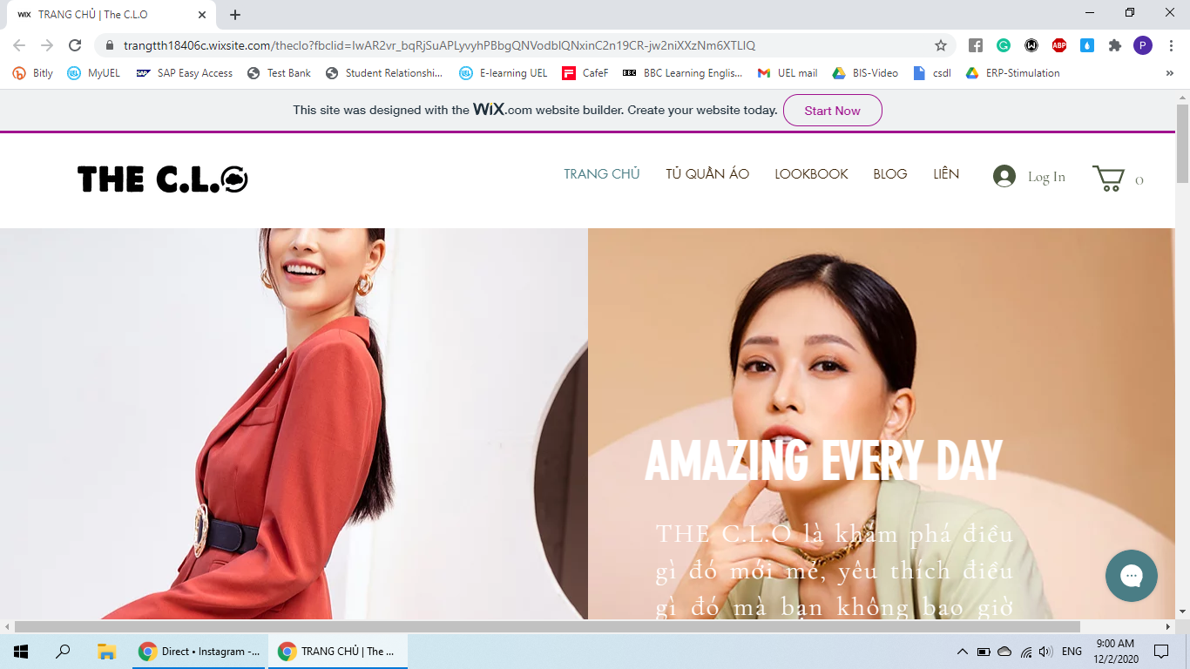

#### Traditional Online Marketing

  - Search engine optimization (SEO) is the practice of increasing the quantity and quality of traffic to your website through organic search engine results.

- Email marketing: sending email to customers to inform to them new products and promotions.

#### Social media platforms

Instagram is one of the most popular social media for younger who interested in fashion and trending.

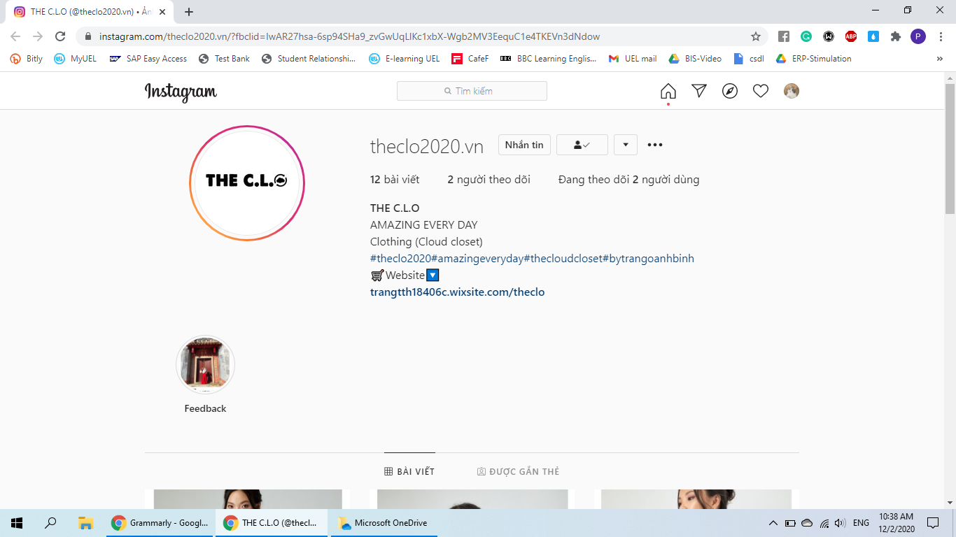

Facebook: most of people at all age has at least one Facebook account so it’s a potential social network to advertise THE C.L.O product and services.

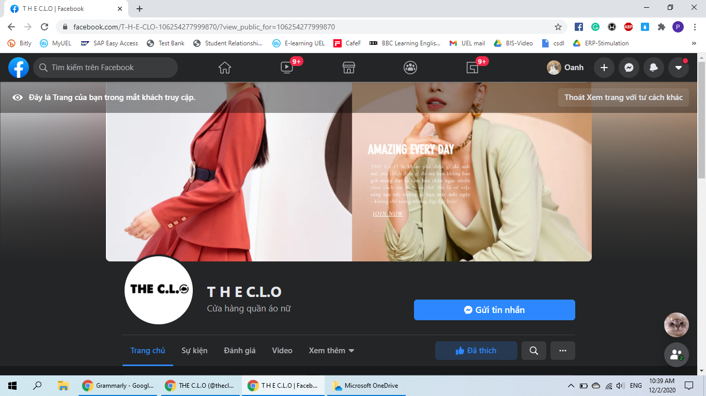

#### Mobile tablet, site, apps

Mobile marketing is a way to make products visible on mobile devices, phones, tablets, smartphones, … Mobile Marketing is not just a new marketing trend. It is really becoming a powerful tool to win attention and interest from customers. By analyze activities of internet user, a smart advertising tools will use these data to recommend suitable products for customer.

### Revenue Stream

Turnover comes from one of two following forms:

* Subscription to a membership - Unlimited Subscription service: Allows customers to rent 5 products, maximum for 1 time, but not limited to the number of product changes. Clients pay for the entire service including the outfit, the number of days they own it, dry cleaning and returns. All of these are included in the rental price.
* Pay for a one-time rental or additional demand for rental products: Customers can come to the showroom to try on the products before book, but can also book up to many sizes and many styles which will be delivered to the door. so that customers can choose a satisfying product that comes with an added cost.
* Customer buys the product again: Customers can retry the product if they want, the purchase price will be deducted over time or the number of times the product has been rented. Prices will be displayed on the app or web always, customers can pay directly through it. Purpose: to bring more profit and especially to reduce inventory.

### Key Resources

#### Website, App

* The CLO will initially deploy the branding announcement and promotion activities through the website and carry out communication on major social networks like Facebook and Instagram.
* On the main website, customers can register for membership and manage personal information, orders, ...
* THE CLO fan page on Facebook and Instagram has the role of advertising the brand as well as supporting customers with answers and advice.
* App will be built later and suitable for operating systems such as iOS, Android, ... Both managers and customers have the right to access and manage certain pieces of information.

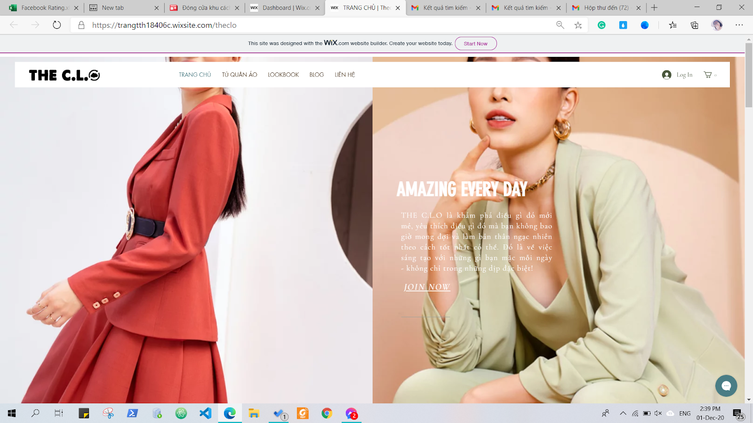

* + 1. Business information management

Business information management consists of many parts such as finance, customer information, suppliers, and products, so it needs an information system to help manage business effectively, reduce costs and multiply. force for business. In customer care, basic information, transaction information and loan return product information will be organized and saved. Both managers and customers have certain permissions for access and editing. The information about partners, products in stock and their status, etc. are organized into business information groups. Financial statements, electronic invoices belong to the company's financial information segment.

* + 1. Payments methods
* Customers can pay directly in cash or through other forms such as e-wallet, internet banking, ...
* To pay in cash, customers can go directly to the store, subscribe to the service package and pay.
* As for the form of payment by e-wallet or Internet Banking, customers can register to buy the service package online through the website https://bit.ly/3lnqkSs and then choose the appropriate form of payment. In the future, THE C.L.O will expand and maintain online forms of payment to save time, increase efficiency,...
  + 1. Logistic

THE C.L.O has a delivery policy for customers, the shipping fee depends on their geographic area. Customers will access the website, select the desired product, add the payment method, then choose the delivery part and fill in the information. The requested products will be checked by staff and  the order is prepared for the shipper to be delivered to customer.

### Key Activities

* Exploited, used thoroughly and effectively on the Internet platform, launched a website to meet the weak market demand. And this is also a great solution for easy business management.
* Building a large data center with data sources taken from the Website. Through this data warehouse, businesses can easily manage each business activity.
* In addition, businesses can apply BI solutions to analyze customer behavior, customer trends, ... as well as make important decisions in the future to bring profits. high for business.

### Key Partnerships

* Enterprises will connect with famous brands to sign contracts for the use of images and models.
* Work with KOLs, beauty bloggers, to increase your site's visibility
* combined with large articles, regularly writing articles to increase the popularity of the Website.
* Associate with the laundry shop for a laundry session. There are signed policies in place to ensure clothes are washed and costs are stable
* Signed with shipping companies, to ensure that clothes can be shipped nationwide within an established time period.
* about Information technology infrastructure, hiring a company specializing in the web to manage and ensure the website is running stably and not lost connection when there is too much access.
* Work with warehouses to build warehouses to ensure that products are carefully stored.

### Cost Structure

* Cost for clothing: connecting with designers, fashion brands to become a partner.
* Brand sponsorship: Here fashion suppliers will benefit that customers will have access to their products, when customers are satisfied, if they have shopping needs, customers can find those brands. Because customers have used it so there is confidence. (if it can be expanded, the number of users increases).
* Buy at a discount price: As mentioned the benefits of the partner brands above, after the sponsorship, we can buy products at a discount because the brand, the designer is a long-term partner, This is beneficial for both sides so it will be easier to sponsor.

- Laundry fee: third-party

- Shipping cost: third-party

- Cost of infrastructure: web host, app build, ...

- Management - operating costs: warehouse management - clothing, management

### 3.9. Marketing plan

#### 3.9.1. Target

Short-term goal:

* Increase popularity on major social networking sites, especially large social networks for young people like Facebook, Instagram, ... because the target audience of the model is young, so it is necessary to focus on the tools have a great influence on them
* Attract the interest of customers and offer programs that encourage them to experience the service
* Building a professional brand image by applying modern technologies in accordance with the development trend of society

Long-term goals:

* Become the most famous brand in this field
* Understanding customers and satisfying them with service quality is the top goal for business to grow and grow.

#### 3.9.2. Product Positioning

* Price of each product: rental products are aimed at young people who are dynamic and sensitive in the trend, always want to assert themselves, so they usually have an average price - high from (500k to over 1 million) is the type of fashion that shows the style of the wearer.
* Information technology foundation: by applying information technology in business management and development, this will be the strength of the model compared to other businesses and it is also a solid foundation for possible compete and stand firm in today's digital technology age
* Big and high-end brands

Some brands offer fashion products:

* NEM Fashion

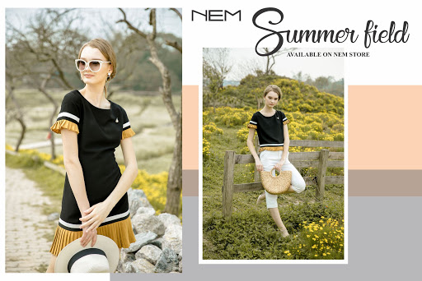

NEM Fashion is the leading fashion brand in Vietnam. Established in 2002, NEM has gradually built up trust and gained a position in the hearts of customers.

Every month, NEM releases more than 500 fashion models. The fashion line of NEM today is very diverse, from high-end products for men and women to mid-range products. The outfits are based on market assessments, research on world fashion trends and the preferences of Vietnamese customers. At the same time, NEM's outfits are always highly appreciated in predicting fashion trends in color gamut, style, material handling ..., becoming the focus of Vietnamese fashion village in every creation. build a new Collection.

* IVY Moda

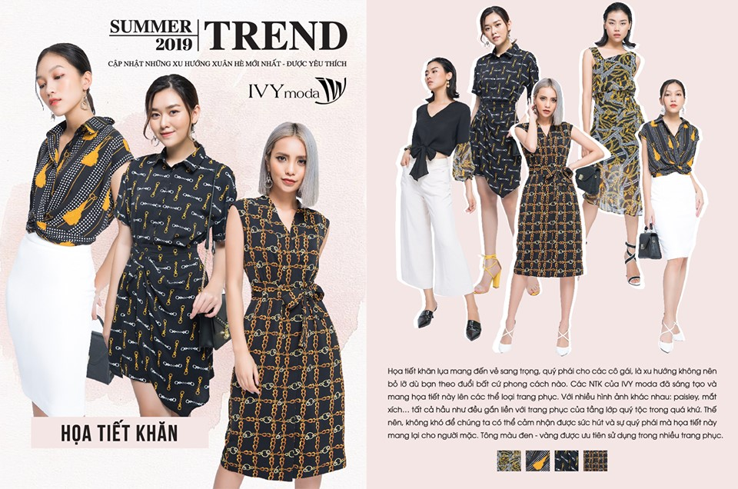

IVY moda is a Vietnamese fashion brand with the desire to bring modern beauty and confidence to customers through the fashion product lines that show off personality and trends. One of the "principles" of IVY moda's design is the diversity, with the desire to bring the wearer the best products with the appearance and, most importantly, his own personality.

* Elise



Feminine, chic and elegant are the first sensations of ELISE's fashion design. Collections are created by Italian fashion designers who combine leading Vietnamese experts to create classy outfits.

ELISE is loved by the standard form on the product, the sophisticated and unique cuts are the decisive factor in ELISE's distinction and reputation. Customers who own ELISE brand products always feel satisfied by each outfit as being tailored to their body. It can be said that ELISE's great success stems from the outfits that adore the body but completely homogeneous and comfortable with the fabric carefully selected by experts.

* Bella Moda

The Fashion Design Joint Stock Company - Bella Moda - Bella Moda brand officially appeared on the office fashion market in March 2010, with over 10 years of existence and development, so far Bella Moda has been present. in big cities such as Hanoi, Hai Phong, Nghe An, Hai Duong, Son La, ...

Bella Moda

The Bella Moda brand focuses on adding value to the design and product quality: constantly updating many new products to diversify options for users, focusing on the selection of high quality materials, focusing on each Small details for each outfit not only to show off the beauty of modern women, but also to bring inspiration to a beginner day.



#### 3.9.3. Marketing Mix(4P)

- Product

Satisfying the needs and satisfying customers is the top factor for a solid business foundation. The fashion products that the fashion rental model brings to customers are diverse in colors, styles, suitable for many styles, ... Besides, product quality is also something of attention. is important to bring comfort and confidence to customers. Fashion products will largely determine the choice and use of the services of the business, so it is necessary to focus on understanding the needs and tastes of customers and meeting those needs.

* Price

Pricing products according to the joint's brand is the strategy applied to the product marketing strategy. Although newly established, we still decided to choose this pricing strategy because we want to build a professional corporate image from the start, targeting the audience with income and needing products to meet demand. make up.

* Place

The distribution of products to customers needs to ensure many factors such as speed and quality of goods. To do this requires a wide chain of stores and a sufficient number of products to promptly respond to customers and an information system that is strong and fast enough to handle and support product distribution. However, the potential customer area is often concentrated in big cities, so the decision to build a product distribution network should pay attention to this point. The stores not only act as intermediaries to deliver products to the customers, but also can come and try the products directly.

* Promotions

Today, with the background in information technology, brand image promotion takes many forms and is very diverse for managers to choose and create a marketing strategy for products or services. Taking advantage of the advantages of technology, product marketing strategies will include advertising services such as through traditional media, SEO tools, Mobile marketing, advertising on the website, ... Cooperation with fashion brands in order to reduce costs of fashion products as well as increase brand popularity, THE CLO can combine with fashion brands to help them advertise products and brands and instead THE CLO will receive get incentives for the cost of buying fashion products.

# CHAPTER 2: WEBSITE DESCRIPTION

## General introduction

Nowadays, when information technology develops, internet coverage is high, leading to many industries developing together. In which, it is impossible not to mention online sales in general and the introduction of online fashion products in particular. Simply because the practical needs as well as the tastes of consumers who want to choose product information carefully, then decide to buy in order to save time and costs.

An extremely effective but not too expensive solution is to invest in an online store to advertise to customers. That is why the investment in THE C.L.O website design is very necessary to help managers earn potential customers, and now online business in e-commerce model is a trend of the world.

The website THE C.L.O is the main tool for customers to access and perform transactions for businesses. THE C.L.O is a website that aims to advertise fashion product rental services, so the website interface needs to be easy to see, focus on fashion trends to attract and attract attention.

As a business website, THE C.L.O is built to meet the essential needs such as helping managers easily update product information, policies, business information. In addition, customers should also ensure that customers can easily use them to register, check information, purchase services and manipulate orders.

## The basic structure of the Website is illustrated

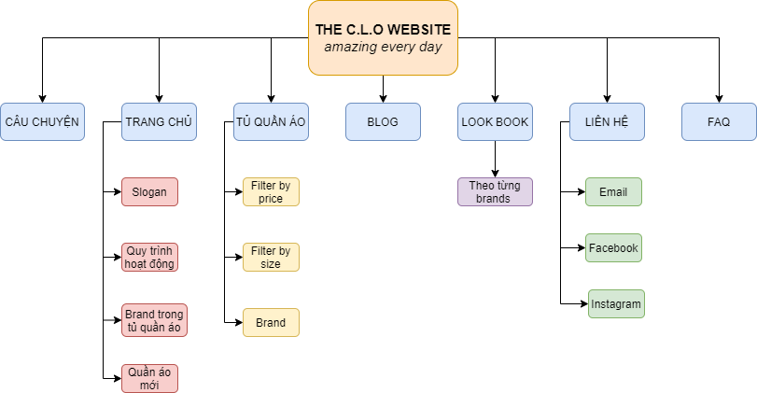

## Detailed description of the main components of the Website

### Header & Footer

*Header*

Header includes buttons About story of business, Home page, Store, Look book, Blog, and Contact.

The header is the part for viewers to identify the brand, the field that the business is aiming for. It also shows that the website content includes items that will provide classified information.

*Footer*

Having a text box for customers can subscribe to become a member of The CLO and links to another page.

### Home page

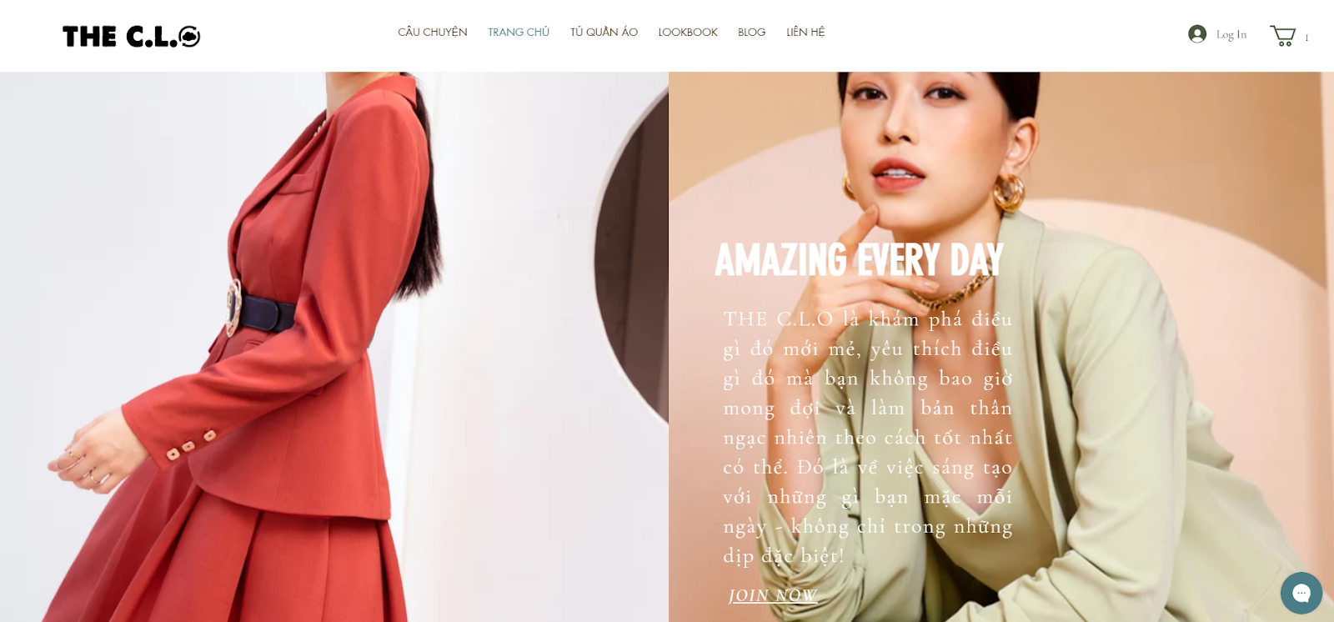

*Describe the slogan of The CLO*

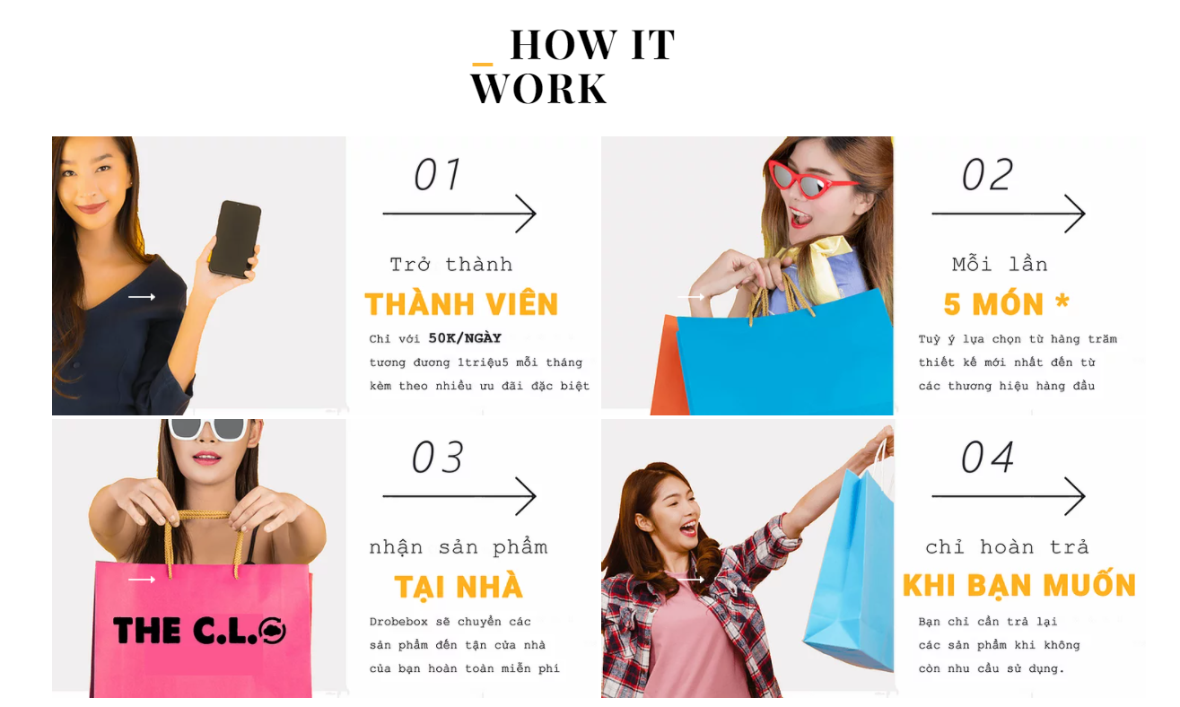

*Describe about how The CLO works.*

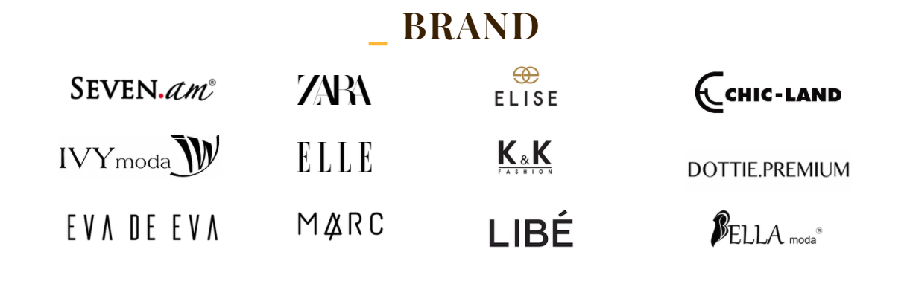

*Brand Logos are third-party of us.*

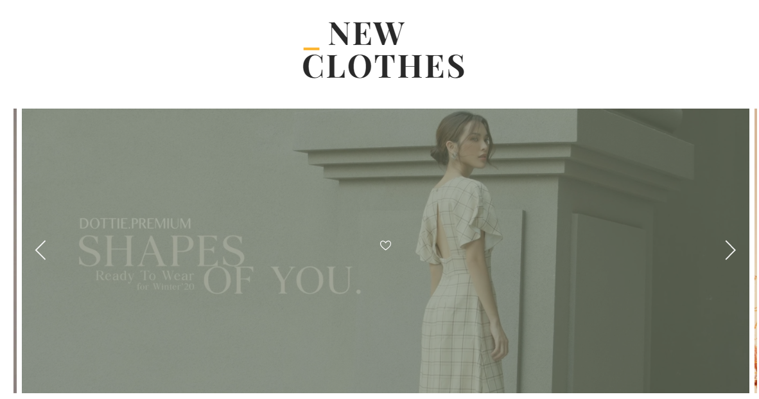

*Update new clothes in Homepage.*

### Sign up & Log in



*New customers can sign up with Facebook, Google or email.*

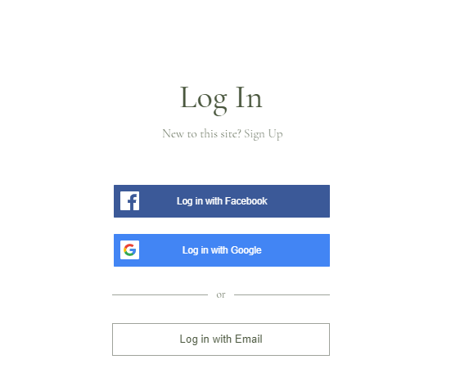

*Members can log in similar to sign up.*

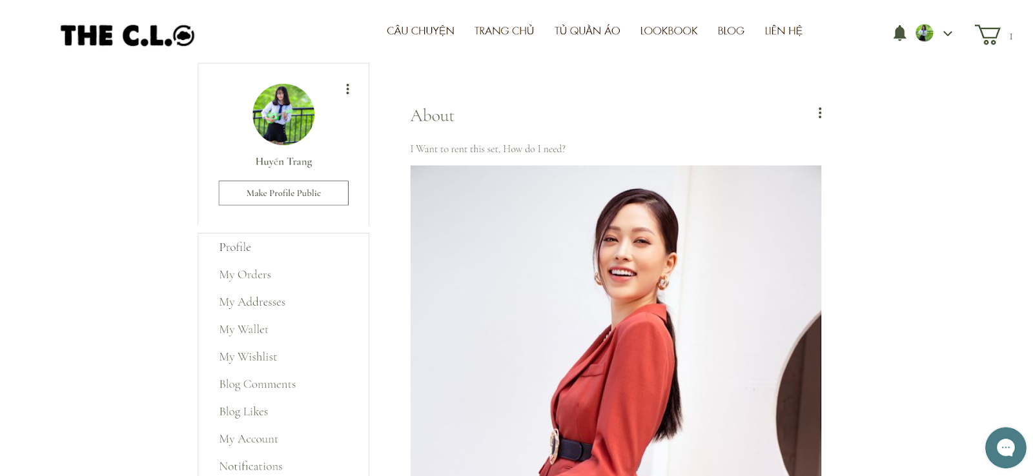

*Profile of a member after log in, they can post information and questions.*

### The cart

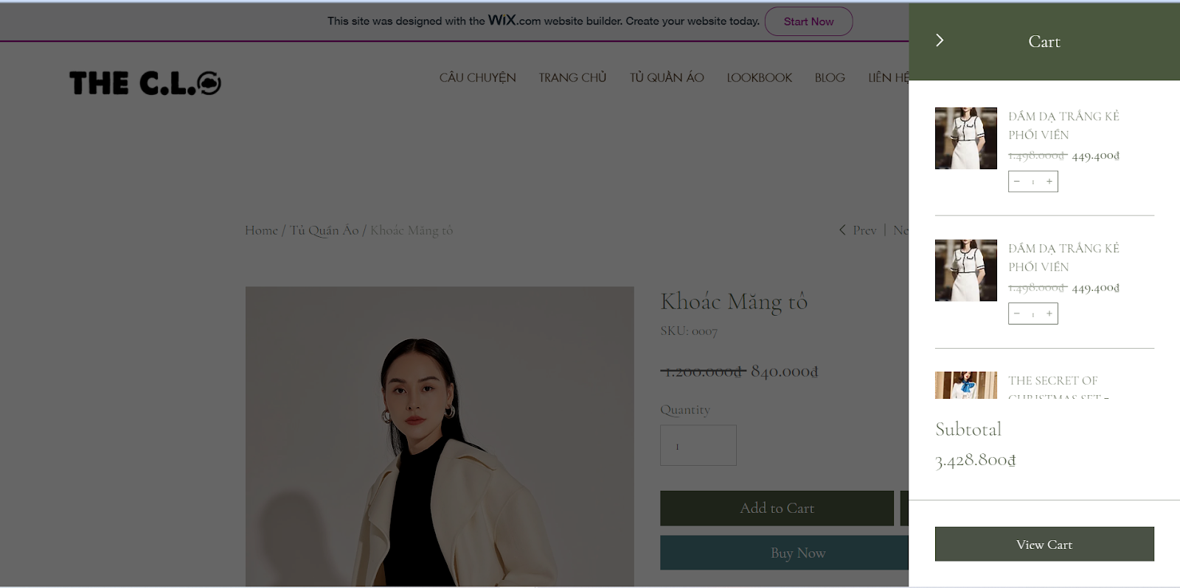

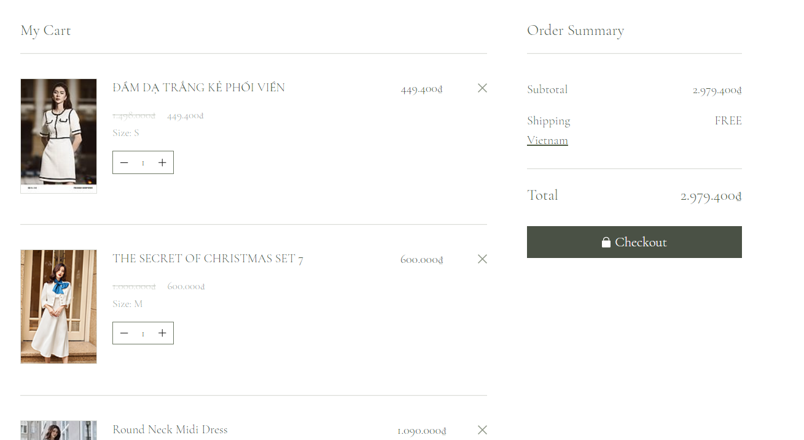

*View full the Cart, then members can checkout and their cart will be shipping in their home.*

### Wardrobe

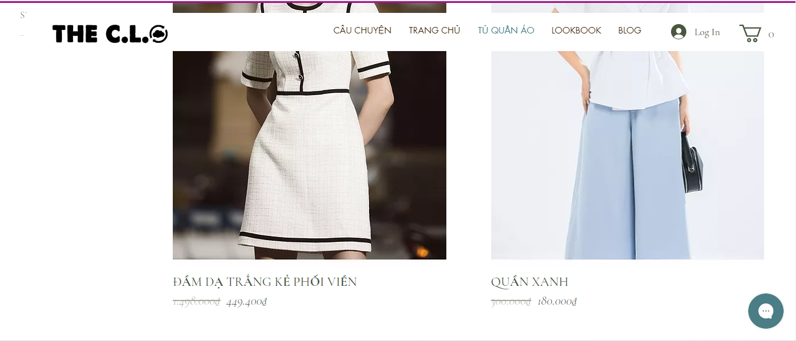

*The list of product include name and price of each product*

### Lookbook

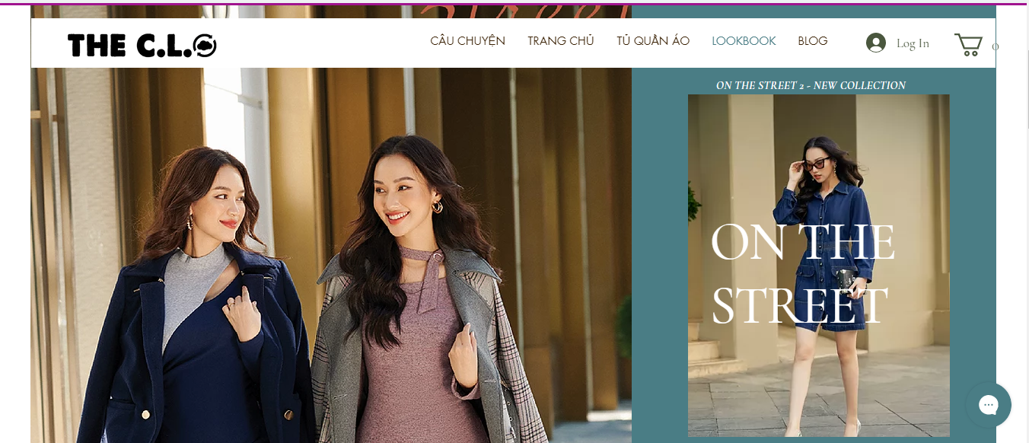

*The list of lookbook and their concept*

### Blog

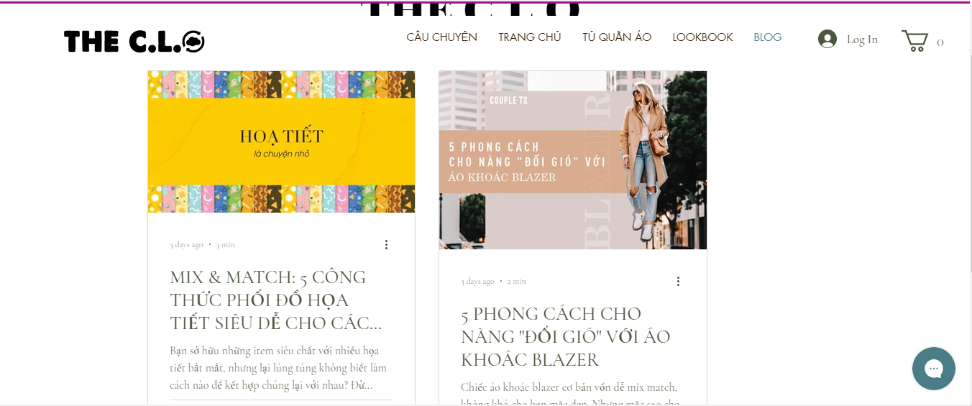

*List of blog issued by topic which help customer achieve more fashion knowledge*

### Contact

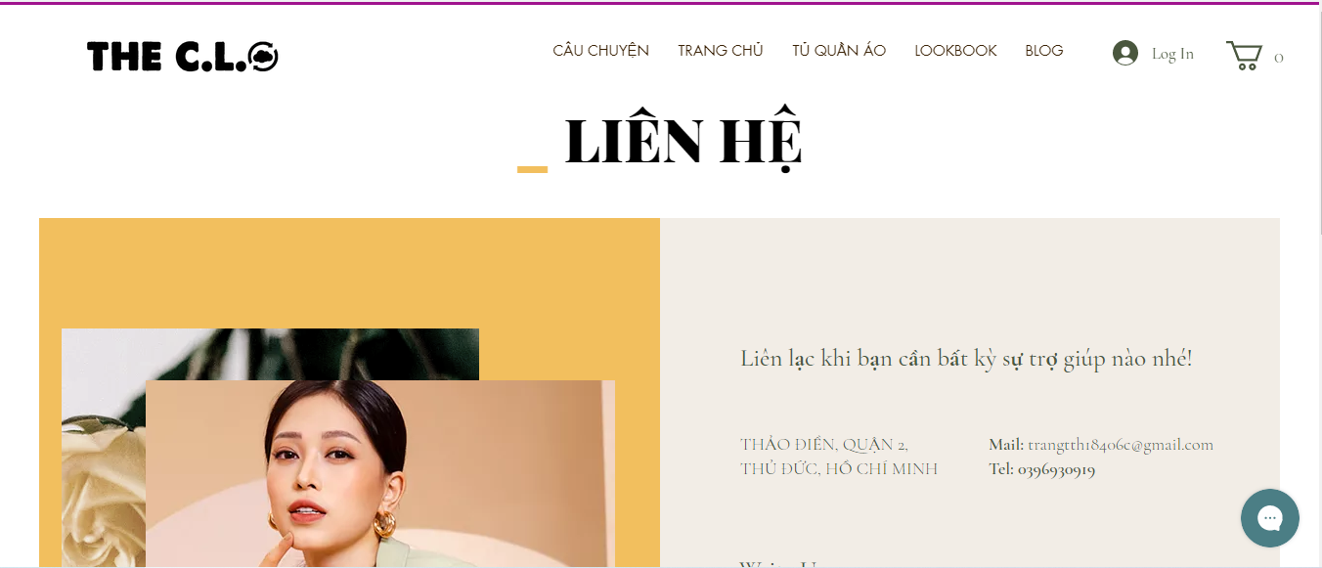

*For support or more details, customer can contact to these following information*

# CHAPTER 3: CONCLUSION

## Project evaluation

### Result

* The topic has applied all the knowledge learned in the learning process of E-commerce such as: E-commerce Infrastructure, Building an E-commerce Presence, E-commerce Security and Payment Systems, E-commerce Business Strategies , E-commerce Marketing and Advertising, Social, Mobile, and Local Marketing, ...
* Through that process, the group has learned more about the formation process, shipping process, operation and problems in e-commerce. From there, understand more about this potential market. Improve skills in searching documents as well as reading comprehension and writing reports in English.
* Team members can arrange time to complete the project on time. As well as increase the ability to self-learn, problem research and interactivity in teamwork.

### Advantage and disadvantage

#### Advantage

* There are many resources available during learning as well as searching on the Internet.
* The topic is close, meeting the dress needs of Vietnamese women, so many people are interested.
* Use an e-commerce platform to modernize this shared business model.
* Because the team has a good background in English, this is considered a great advantage in the process of searching documents and writing reports.

#### Disadvantage

Since this is a new business field in Vietnam, it is very difficult to make decisions for each activity. This requires the group to have a certain understanding of the market, economics as well as current technologies.

## Development

* Application building on phones, tablets to meet ordering needs becomes easy.
* In the future, the activity scope of the CLO Website will be expanded to many other fields: high fashion, accessories, ...
* Sales activities will take place quickly, not only with the Website, THE CLO will open a number of stores nationwide with the desire to provide the customer experience with the products offered. from the store.
* The target customers will be expanded, not only for office women, but also by five genders, as well as clothes suitable for each age.
* Once operating effectively in the market, THE CLO will expand its B2B model. The integration between B2C and B2B with the desire to attract more customers and businesses to pay attention to this wonderful business field.
* Using virtual reality technology to enhance the user experience. Through it, users can see their own image in the selected subpage. From there, decide whether to rent that extra set or not.
* THE CLO will have a segment of “PRO” accounts to provide premium clothing at a fee of 100,000 VND/day. This is to meet the needs of customers who often participate in events, parties, ...
* Strengthen customer relationships through volunteer activities such as donating clothes. This is an effective way to " polish" for THE CLO.
* Implementing and developing ERP system for THE CLO. This is an effective tool in corporate governance. Thanks to the minimization of costs in the operation and implementation, the ERP system helps THE CLO to save significantly costs as well as resources during the operation.

# REFERENCE

* Kenneth C. Laudon, Carol Guercio Traver (2017). E-Commerce 2017, Pearson.
* Rent the way

< <https://www.renttherunway.com/>>

* Tulerie – Peer to Peer clothing rental community

< <https://tulerie.com/>>

* Will the ‘Sharing Economy’ Work For Fashion?

**<** <https://www.businessoffashion.com/articles/technology/will-the-sharing-economy-work-for-fashion-rent-the-runway-rental>**>**

* Running Lean— Phác thảo một Lean Canvas

< <https://longnguyen.site/running-ph%C3%A1c-th%E1%BA%A3o-m%E1%BB%99t-lean-canvas-p1-252dff77d41b>>

# APPENDIX - Team working process report

## Member list

|  |  |  |  |  |
| --- | --- | --- | --- | --- |
| No. | Fullname | Student’s ID | Role | Email |
| 1 | Mai Nguyễn An Bình | K184060777 | Leader | [binhmna18406c@st.uel.edu.vn](mailto:binhmna18406c@st.uel.edu.vn) |
| 2 | Nguyễn Lê Phương Oanh | K184060797 | Member | [oanhnlp18406c@st.uel.edu.vn](mailto:oanhnlp18406c@st.uel.edu.vn) |
| 3 | Trịnh Thu Huyền Trang | K184060811 | Member | trangtth18406c@st.uel.edu.vn |

## Rules of work of the group

* How the group works: combine online (Facebook, Messenger, Zoom, Google Suite, Email,...) and meet offline (discuss on campus, at the cafe, and work together).
* Period of regular meetings: total meetings
* Offline is 5 times, the duration is 45-60 minutes, in which there is a meeting at the library and the whole group doing their work has been divided for 3 hours. The group arranged a meeting for members to review to make sure each member understood the report.
* Online is 4-5 times, due to the disease situation Covid-19 this is an irregular meeting channel because the majority of each meeting will handle and divide specific tasks for each member. Therefore, the majority of the meetings were of nature to resolve the eyes and unify the meeting schedule for the whole group.
* Regulation group
* Arrive on time for meetings, both Offline and Online.
* Absent members must have a good reason and must be accepted. That member must ensure the understanding and execution of the group's work through communication from the group.
* Complete the task on time, each time will be deducted% of work completion.
* Members must be responsible for their duties, the sketchy work will be lost% of completed work and must make corrections and changes if required.
* Members must have a cooperative attitude, contribute opinions to the overall work of the group.

## Assign tasks and completion schedule

### Task Table

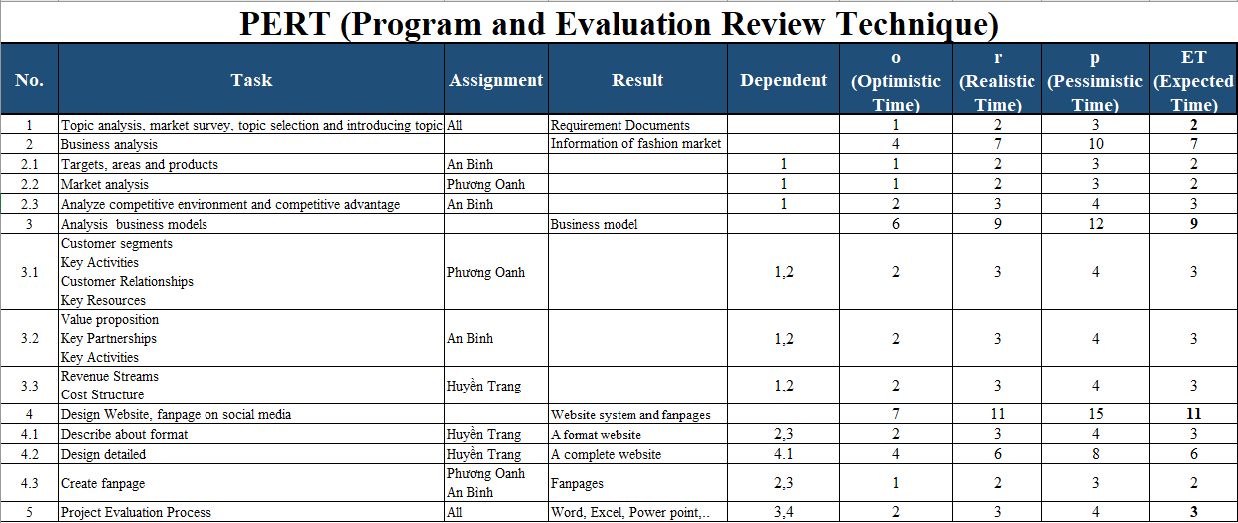

### PERT Chart

#### AOA (Activity On Arrow)

#### AON (Activity On Node)

### GANTT Chart

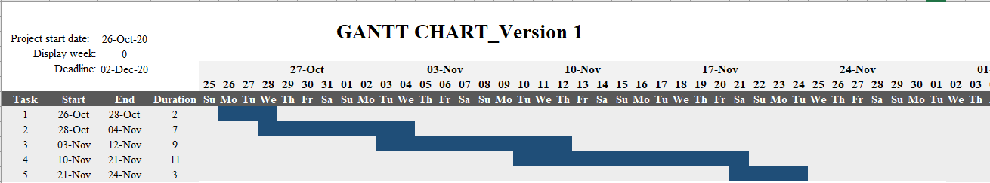Desired timetable

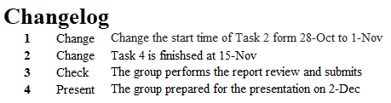Changelog in team working process

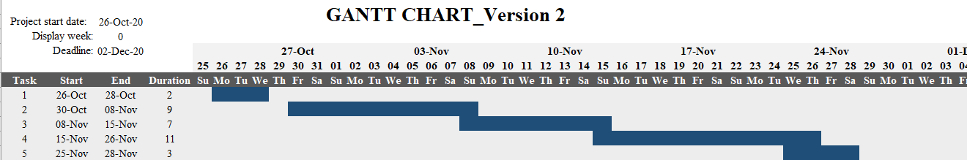Real time schedule

## Comment from the group

|  |  |  |
| --- | --- | --- |
| **Fullname** | **Level of contribution** | **Comment from the group** |
| Mai Nguyễn An Bình | 100% | -Complete the task leader  -Has a sense of responsibility for the task  -Give comments on the work process |
| Nguyễn Lê Phương Oanh | 100% | -Provide a lot of additional information that is needed for the report  -Has a sense of responsibility for the task  -Give comments on the work process |
| Trịnh Thu Huyền Trang | 100% | -There are many good contributions to the working process: raise the topic for the team and implement the Canvas model application.  -Has a sense of responsibility for the task  -Give comments on the work process |

The team leader assesses the level of contribution and is approved by the members.

## Summary

* Overview of the teamwork process: Effective working methods and effective working process because the team always prioritizes solving difficult problems and needs interaction, contribute ideas and choose the best solution, which is agreed by the members. tablets.
* Regulation group: some members are still late to be present, making content incomplete.
* Commenting on the results of the thesis: in general, the results of the project are completed. Unrealized issues and development directions are presented in Chapter 5: Conclusions in the report.